Lagged cross-correlation: GBPUSD and USDJPY
Method 12 / daily log returns / K_max=10 / Alpari D1 full available history

Study setup
Logical pair: GBPUSD , USDJPY
Broker symbols: GBPUSD_i , USDJPY_i
Snapshot: 2026-11-03_majors_alpari_D1
Timeframe: D1
Matched return window: 1999-01-05 to 2026-11-02 (UTC bar dates)
Matched return count n: 7200
Dropped unfinished last bar dated 2026-11-03 UTC after a tick-volume check against the prior complete day.
Lag definition: rho_X->Y(k) = Corr(x_t, y_{t+k}) on matched D1 bars
K_max = 10; headline lag k = 1 (both directions)
Complete matched rows (Excel): GBPUSD-USDJPY_Lagged_D1.xlsx
Complete matched rows (HTML table): GBPUSD-USDJPY_Lagged_D1_data.html

Method carried forward
Lagged cross-correlation measures Pearson correlation between matched daily log returns of close, ln(close_t / close_t-1), after shifting one series forward by k bars on the matched panel. Quotes are not inverted. rho_{X->Y}(k) = Corr(x_t, y_{t+k}) with n_k = n - k. K_max = 10 is fixed before estimation. The headline is the pre-specified lag k = 1 in both directions. k = 0 is the same-bar side check. The lag inside 1..10 with the largest absolute rho is stored as a descriptive column only; it is not a selected result. This is a linear screen, not proof of forecast edge, economic cause, or a trading signal.

Results (headline k=1)
rho_GBPUSD->USDJPY(1): -0.007036 (n=7199)
95% Fisher interval GBPUSD->USDJPY: [-0.030132, 0.016067]
rho_USDJPY->GBPUSD(1): 0.037165 (n=7199)
95% Fisher interval USDJPY->GBPUSD: [0.014076, 0.060214]
Same-bar rho(k=0): -0.198556
Largest |rho| among k=1..10 (descriptive only, not selected): GBPUSD->USDJPY k=4 rho=-0.015802; USDJPY->GBPUSD k=1 rho=0.037165

CCF table
k | rho_GBPUSD_to_USDJPY | n_GBPUSD_to_USDJPY | rho_USDJPY_to_GBPUSD | n_USDJPY_to_GBPUSD
0 | -0.19855551 | 7200 | -0.19855551 | 7200
1 | -0.00703633 | 7199 | 0.03716457 | 7199
2 | 0.00134075 | 7198 | 0.01457062 | 7198
3 | -0.00394998 | 7197 | -0.01583975 | 7197
4 | -0.01580224 | 7196 | -0.00488909 | 7196
5 | 0.00647004 | 7195 | 0.00183139 | 7195
6 | 0.00946151 | 7194 | -0.0129085 | 7194
7 | 0.01553089 | 7193 | 0.01433373 | 7193
8 | 0.00928528 | 7192 | -0.00923182 | 7192
9 | -0.01228554 | 7191 | -0.00752866 | 7191
10 | -0.0037996 | 7190 | 0.00877417 | 7190

Conclusion
At the pre-specified lag k=1 for GBPUSD and USDJPY, rho_{GBPUSD->USDJPY}(1) = -0.0070 (n=7199) and rho_{USDJPY->GBPUSD}(1) = 0.0372 (n=7199). Same-bar rho(k=0) = -0.1986. Largest |rho| among k=1..10 is descriptive only: GBPUSD->USDJPY at k=4 (-0.0158); USDJPY->GBPUSD at k=1 (0.0372). This is a linear screen, not forecast proof or a trading signal.

Charts
Daily closes

Daily log returns

CCF both directions k=0..10
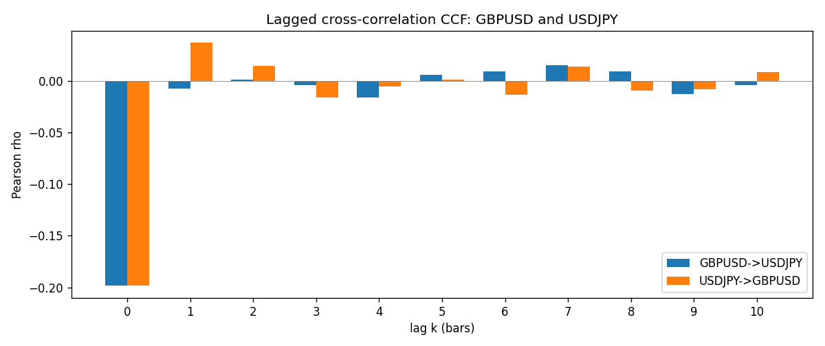

Data report
Every matched row is stored in the sibling Excel workbook named GBPUSD-USDJPY_Lagged_D1.xlsx (sheet matched_rows). The CCF sheet holds rho(k) for k=0..10. Embedding all rows as a Word table is impractical; the Word file holds column summaries and the first and last 15 rows.
Columns: time, GBPUSD_open, USDJPY_open, GBPUSD_high, USDJPY_high, GBPUSD_low, USDJPY_low, GBPUSD_close, USDJPY_close, GBPUSD_tick_volume, USDJPY_tick_volume, GBPUSD_spread, USDJPY_spread, GBPUSD_real_volume, USDJPY_real_volume, GBPUSD_log_return, USDJPY_log_return
Column summaries (matched calculation rows)
column | count | mean | std | min | 25% | 50% | 75% | max
GBPUSD_open | 7200 | 1.5159933 | 0.21821503 | 1.06854 | 1.3249725 | 1.51133 | 1.63163 | 2.1066
USDJPY_open | 7200 | 113.81122 | 19.205564 | 75.693 | 104.42925 | 110.991 | 120.69125 | 163.824
GBPUSD_high | 7200 | 1.5222906 | 0.21878569 | 1.08366 | 1.329785 | 1.518035 | 1.638315 | 2.1161
USDJPY_high | 7200 | 114.30876 | 19.267108 | 76.001 | 104.8815 | 111.4435 | 121.26 | 163.978
GBPUSD_low | 7200 | 1.5096683 | 0.2174426 | 1.03518 | 1.319445 | 1.50319 | 1.6243 | 2.0983
USDJPY_low | 7200 | 113.28793 | 19.133561 | 75.402 | 103.89 | 110.5305 | 120.17 | 163.628
GBPUSD_close | 7200 | 1.5160611 | 0.21817876 | 1.06879 | 1.3250775 | 1.511235 | 1.63193 | 2.1065
USDJPY_close | 7200 | 113.82409 | 19.220954 | 75.811 | 104.42 | 111.028 | 120.6855 | 163.851
GBPUSD_tick_volume | 7200 | 94838.03 | 153554.65 | 62 | 10001.75 | 52905.5 | 91812.25 | 1273370
USDJPY_tick_volume | 7200 | 106136.9 | 179308.31 | 149 | 9925 | 53095 | 92761 | 1803508
GBPUSD_spread | 7200 | 26.967917 | 19.192953 | 0 | 11 | 20 | 50 | 50
USDJPY_spread | 7200 | 20.325556 | 17.633971 | 0 | 6 | 11 | 30 | 50
GBPUSD_real_volume | 7200 | 3.5565837e+09 | 8.4444068e+10 | 0 | 0 | 0 | 0 | 2.4038164e+12
USDJPY_real_volume | 7200 | 3.470121e+10 | 1.6077679e+11 | 0 | 0 | 0 | 0 | 3.8834203e+12
GBPUSD_log_return | 7200 | -2.396e-05 | 0.00564572 | -0.08388241 | -0.0031301 | 3.232e-05 | 0.00317911 | 0.03112653
USDJPY_log_return | 7200 | 4.769e-05 | 0.00620489 | -0.03908203 | -0.00320192 | 0.00011421 | 0.00340709 | 0.05184024
First 15 matched rows (selected columns)
time | GBPUSD_close | USDJPY_close | GBPUSD_log_return | USDJPY_log_return
1999-01-05 | 1.6547 | 111.92 | -0.0028966287 | -0.00017868311
1999-01-06 | 1.6537 | 112.77 | -0.00060452184 | 0.0075660159
1999-01-07 | 1.6502 | 111.33 | -0.002118709 | -0.012851583
1999-01-08 | 1.6405 | 110.8 | -0.0058954193 | -0.0047719894
1999-01-11 | 1.6312 | 109.02 | -0.0056851331 | -0.016195423
1999-01-12 | 1.6349 | 112.6 | 0.0022657001 | 0.032310364
1999-01-13 | 1.6499 | 113.52 | 0.0091330396 | 0.0081373171
1999-01-14 | 1.6531 | 113.52 | 0.0019376331 | 0
1999-01-15 | 1.6502 | 114.15 | -0.0017558204 | 0.0055343401
1999-01-18 | 1.6522 | 114.16 | 0.0012112405 | 8.7600193e-05
1999-01-19 | 1.6553 | 113.52 | 0.0018745281 | -0.0056219403
1999-01-20 | 1.6472 | 112.91 | -0.0049053846 | -0.0053879917
1999-01-21 | 1.6524 | 113.87 | 0.0031518998 | 0.0084664056
1999-01-22 | 1.6565 | 114.56 | 0.0024781662 | 0.0060412564
1999-01-25 | 1.6585 | 113.72 | 0.0012066366 | -0.0073594164
Last 15 matched rows (selected columns)
time | GBPUSD_close | USDJPY_close | GBPUSD_log_return | USDJPY_log_return
2026-10-13 | 1.32534 | 158.305 | 0.0036434319 | -0.0018932826
2026-10-14 | 1.31884 | 158.317 | -0.0049164679 | 7.5800166e-05
2026-10-15 | 1.32757 | 158.024 | 0.0065976411 | -0.0018524319
2026-10-16 | 1.33257 | 157.964 | 0.0037592051 | -0.00037976126
2026-10-19 | 1.33024 | 158.517 | -0.0017500314 | 0.0034946841
2026-10-20 | 1.3377 | 158.16 | 0.0055923442 | -0.0022546642
2026-10-21 | 1.33937 | 158.108 | 0.0012476328 | -0.00032883504
2026-10-22 | 1.33967 | 156.755 | 0.00022396082 | -0.0085942669
2026-10-23 | 1.33684 | 156.81 | -0.0021146949 | 0.00035080446
2026-10-26 | 1.33359 | 157.458 | -0.0024340661 | 0.0041238746
2026-10-27 | 1.33044 | 157.894 | -0.0023648393 | 0.0027651658
2026-10-28 | 1.33254 | 157.743 | 0.0015771808 | -0.00095679538
2026-10-29 | 1.33733 | 157.683 | 0.0035881935 | -0.00038043789
2026-10-30 | 1.33913 | 157.516 | 0.0013450605 | -0.0010596481
2026-11-02 | 1.3406 | 157.933 | 0.0010971256 | 0.0026438521

